SELECT A LOCAL STUDY SITE

Sometimes the biggest challenge to getting students from the classroom to the field is trying to figure out where you might have access to public lands. Below are some tips and tricks to help you get your students out into wildlands in your local community.

STEP 1: Start with a birds-eye-view.

When we are driving along in our car, it can be hard to see what lies beyond those stretches adjacent to roadways. Easy access to satellite imagery can help take the guesswork out of where you might start to look for a good field site.

Go to http://maps.google.com and take a quick look at the satellite imagery for your surrounding area. The display will default to the MAPS view. To toggle to the SATELLITE view, simply click on the icon in the bottom left-hand corner.

Type in the name of your town or a local feature to begin your search nearby. Zoom in and out and pan around the landscape until you find something that looks like a place you might be interested to visit.
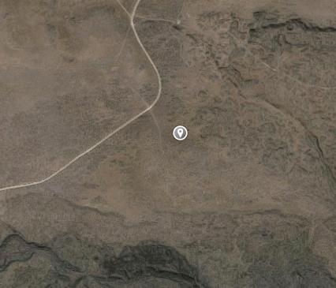
Once you locate a suitable site, click your mouse over the site. Google will automatically drop a marker where you clicked on the map. You’ll see the placemarker appear in the information window on the top right where Google conveniently displays the latitude and longitude of the placemark. Keep in mind that all Google imagery uses units of latitude and longitude in decimal degrees and the map datum is WGS84. This will come in handy if you are entering the coordinates into your GPS.

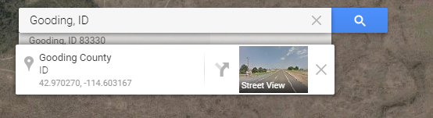

STEP 2: Explore land ownership.

So you’ve found what appears to be a great site nearby with good access and to some wildlands. Now how do you know if you public access is allowed? Well, one of the best ways to determine if your site is publicly managed is to take a look at the landownership map.

Idaho Fish and Game has a great resource for this job. Simply search for the terms “Idaho Hunt Planner Map” or follow this link http://fishandgame.idaho.gov/ifwis/huntplanner/mapcenter/.
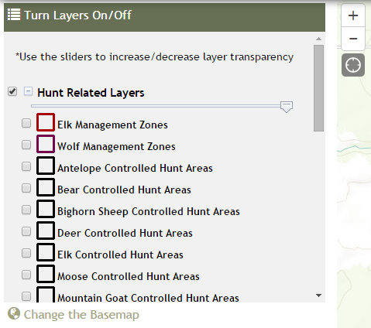
Click to turn off
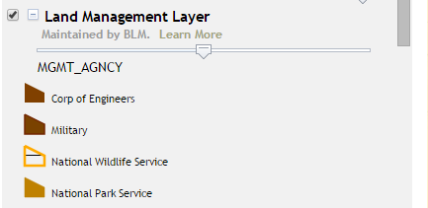
The map will display the entire state with an overlay of the hunting units. First, you’ll want to zoom into the nearby area. The map legend is displayed on the right side of the page. Then you’ll want to turn off the hunting unit layer that initially displays and then scroll down to Land Management Unit and check the box. This will overlay the landownership on the map. Refer to the legend and corresponding color theme.
Click to turn on

The map has a search feature that allows you to enter the map coordinates from step 1. You can also start with this map and work backwards to step 1. For example, find some BLM managed land that is close to your office then use Google maps to find the right roads to get there.
*Note: Google Maps lists latitude first and longitude second
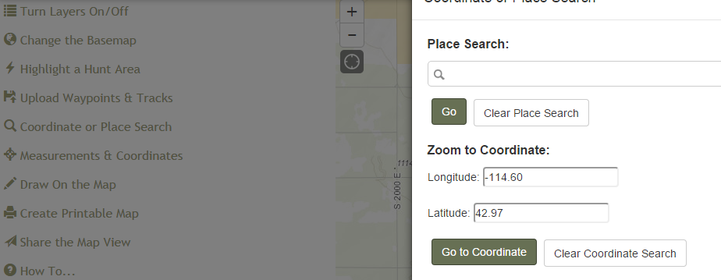
STEP 3: Navigate yourself there.

Take the latitude and longitude coordinates and either make a waypoint in your GPS to navigate to the site in the field. If you have a smartphone, you can also open up the Google map application and enter the coordinates into the search bar. Google accepts coordinate format as dd.dddddd, -ddd.ddddd or dd°mm'ss.s"N dd°mm'ss.s"W. This little trick lets you use your phone navigator to guide you as you drive.

